UI Layout

Hao YAN

Main menu:

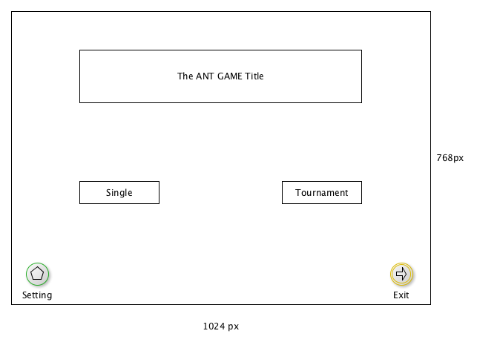

Two player model: single and Tournament

Allow full screen or enlarge

Allow exit in full screen model

Background could be an ant wallpaper or anything else, even a short VT

Bottoms:

Single and Tournament: same size, different color suggested

Setting: may applies a kind of gear icon

Exit: out-door icon

Single Mode

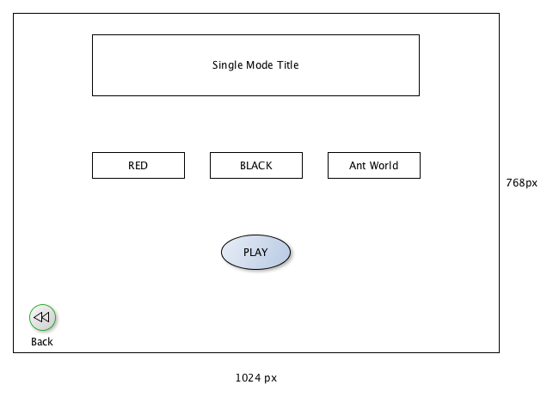

|  |  |
| --- | --- |
| Bottom Name | Result |
| RED | Upload the red ant brain |
| BLACK | Upload the black ant brain |
| Ant World | random |
| PLAY | Start to play when the ant brain is uploaded, otherwise remain grey and cannot be clicked. |
| Back | Back to main menu |

Tournament Mode

// empty temp